SATCOP

Proposal for Vehicle Tracking System
Satcop tracker

For CLIENT

By

SATCOP INDIA

Confidential Information

This document is confidential to SATCOP INDIA and CLIENT (“Client”). This document contains information and data that SATCOP INDIA considers confidential and proprietary (“Confidential Information”).
Confidential Information includes, but is not limited to, the following:
- Corporate, employee and infrastructure information about SATCOP INDIA
- SATCOP INDIA ’ project management and quality processes
- Customer and project experiences provided to illustrate SATCOP INDIA capability
Any disclosure of Confidential Information to, or use of it by a third party will be damaging to SATCOP INDIA. Ownership of all Confidential Information, no matter in what media it resides, remains with SATCOP INDIA.
Confidential Information in this document shall not be disclosed outside the buyer’s evaluators and shall not be duplicated, used, or disclosed – in whole or in part – for any purpose other than to evaluate this document without specific written permission of an authorized representative of SATCOP INDIA.

Table of Contents
1.1 Background & Objectives 5
1.2 Our understanding of CLIENT present infrastructure. 5
1.3 Requirements. 5
2. PRoposed solution 6
3. Why SATCOP INDIA 7
3.1 SATCOP INDIA Expertise: 7
4. Proposed Solution 8
4.1 Overview 8
4.1.1 Global Track Components 8
4.1.2 Vehicle mounting unit 9
4.1.3 Communication network 10
4.1.4 Vehicle Tracking portal 11
4.1.5 Features - Geo-Fencing 12
4.1.6 Features - Locations and Routes 12
4.1.7 Features - Locating Vehicle on the map 12
4.2 Reporting: 12
4.3 Benefits : 13
4.4 Implementation Steps 13
5. Assumptions 14
5.1 Requirements / Scope related 14
6. Execution Methodology 15
6.1 Global Delivery Model 15
6.1.1 Critical Success Factors 16
6.1.2 Optimal Onsite-Offshore Mix 16
6.1.3 Benefits: 17
6.2 System Integration 17
I. Dashboard: 17
II. Consolidated view of all vehicles: 17
III. Map view of one vehicle: 18
IV. Offline tracking: 18
V. Trip details: 19
VI. Trip Summary: 19
VII. Stoppage 20

  - Background & Objectives
.

Satcop tracker (Vehicle tracking solution) from SATCOP INDIA shall provide online web enabled real time tracking of CLIENT’s vehicles. It will provide full visibility of all vehicles on single screens, which will help client to utilize the resources in efficient and cost effective way. It will also help in preventing the unwanted movement and late delivery/dispatch of critical supplies from CLIENT.

It is expected that a strategic VTS solution will allow long term improvement of vehicle services and major reduction in the inconvenience caused to the CLIENT’s vehicle operations. It will enable an improvement in quality of services with reduction in overall cost of ownership. CLIENT can foresee savings with help of accurate and flawless billing for leased vehicles. A reconciliation report generated by Satcop tracker of kilometer run by each vehicle can be used for leased billing.

Additionally Satcop tracker will help in improved coordination among various modes of transport.

Why SATCOP INDIA
  - SATCOP INDIA Expertise:
SATCOP INDIA, Headquartered in Pune, IT and engineering hub of India. SATCOP INDIA is promoted by well know young technocrats having diversified experience in the field of software development, maintenance and product development. SATCOP INDIA provides a complete end-to-end solution to address all the industrial needs of all businesses. SATCOP provides consultancy and software development services on RFID based ERP systems. At SATCOP INDIA, our focus is to deliver solutions to customer, which will help them to increase shareholders wealth. Our aim is to provide a bridge between customer processes & latest technology.
SATCOP is committed to providing a unique package of cost-effective solutions, quality service and complete satisfaction to customers by continuous innovation and R&D, focusing on end user needs and building strategic partnerships with solution providers and system integrators.
- Client has approached SATCOP for the development and deployment of bespoke vehicle tracking system. Our solution intends to answer the following queries:
- Are my vehicles deviating from their specified routes?
- Will my deliveries will be on time?
- Is my driver is driving safely?
- How much each vehicle is running on any given day?
- Which on my vehicles is closest to my delivery locations?
The above proposal is to provide professional solution & services required by client that includes consultancy, business process solutions, site survey, implementation, installation and deployment and other related supports.

Proposed Solution
  - Overview
Satcop tracker (GT) is product from SATCOP which provides location-based solutions and services that track or monitor moving objects such as trucks, luxury bus, containers, ambulances, fire brigade units etc suing Global positioning system (GPS) and GPRS (General Pack Radio Service) .. Satcop tracker is an integrated hardware/software wireless solution designed to track and monitor mobile clients such as security vehicles, commercial trucks and field service vehicles. GT enables for on-line / off-line tracking of vehicles and store, represent, display data of moving objects which is then transmitted to the vehicle tracking server via wireless networks. SATCOP INDIA’s Vehicle Tracking System provides near to real-time services for tracking vehicle through desktop based and dynamic web based indexing for moving objects. It consists of two major components – Vehicle tracking unit (receiver) and Vehicle tracking system portal which will be maintained at the control room.

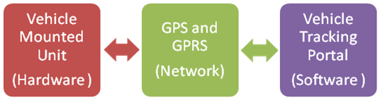
Global Track Components

- SATCOP FM8888 - Vehicle mounted unit (Hardware):
  - GPS device - This consists of an in build GPS receiver and GSM interface. There are various different products are available in the market depending on the customer or application requirement. Each device consists of a protocol and this is interfaced with the portal. Whenever there is new unit is added in the application it is interfaced with the portal.

- Communication Network: This is useful to transfer the data from vehicle mounted unit to the control room. This GPS helps to measures and records the following parameters:
  - Date and Time
  - Speed.
  - Latitude and Longitude using the GPS receiver.
  - Control for Vehicle Immobilization.
These parameters are then sent to the portal using the local GPRS communication service of GSM/2G mobile Network.

- Vehicle tracking portal: This is a web application which is situated in a control room. This is a secure portal which enables to manage the Vehicle mounted units (Vehicles), know the current position of the vehicles, associate geo fencing rules, raise appropriate alerts and perform remote configuration. The portal is completely customizable and easy to access.

Vehicle mounting unit

CONTENT | SPECIFICATIONS
Dim. | 87 * 57 * 25 (mm)
Weight | 0.459kg
Network | GSM/GPRS
Band | 900/1800/1900MHz or 850/900/1800/1900MHz
GPS chip | SiRF IV chip
GPS sensitivity | -159dBm
GPS accuracy | 5 Mts
Work Voltage | DC 9V－12V
Standby work current | < 30mA
Storage Temp. | -40°C to +85°C
Operation Temp. | -20°C to +70°C
Humidity | 5%--95% non-condensing

General Features:
  - Satellite tracking (GPS)
  - Stolen vehicle recovery
  - Over-speeding alert
  - Geo fence
  - Park fence alert
  - Built-in flash memory
  - SMS interface
  - Web interface
  - Hidden microphone to listen to conversations in vehicle
  - SOS button to report emergency
  - Customized reports
Reporting Features:
  - Distance report
  - Speed report
  - Trip report
  - Geo fence report
  - Park fence report
  - Top speed report
  - Vehicle idling report
  - Vehicle stationary report
Alerting Features:
  - Movement alert
  - Speed alert
  - Geo fence alert
  - Park fence alert
  - Top speed alert

Communication network

  - Satellite to GPS device
  - GPS device to GPRS tower via SIM card
  - GPRS tower to webportal

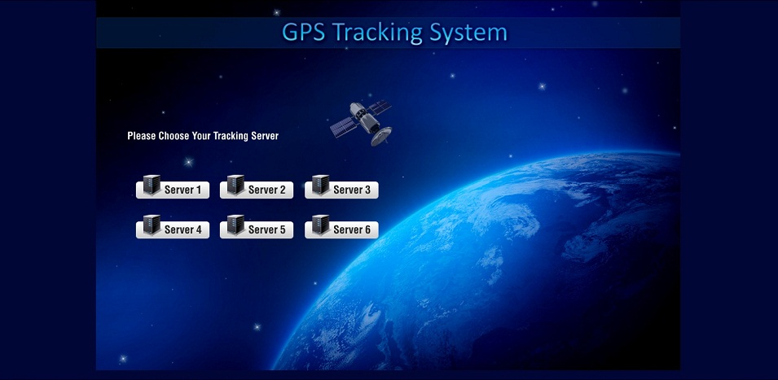
Figure 1: High Level Solution Diagram

Vehicle Tracking portal

The VTS web application provides a dashboard of all the vehicles the customer wants to monitor. The screen provides the live status of vehicles like current location, status, speed, etc. Location of all vehicles can also be seen on the map. Online tracking will be done as below:
- Server will listen on a dedicated TCP port for the location updates from vehicle
- Device installed inside the vehicle will collect the data from GPS receiver, connect to server using GPRS and post the data on the port.
- Server, upon receiving the data, will store the data in database
- VTS Dashboard will fetch the data from the database and present it to the user who will be monitoring the vehicles.
Alternatively, customer can also be able to poll for the status of particular device. He can send the command using the web interface to particular vehicle, which will send the required information in response to the given command. Sequence of data exchange is as below:
- Customer will initiate the command using the web portal.
- Command will be inserted in database with status “PENDING”
- TCP Server will check the database for commands with pending status and send it to the destination vehicle.
- Vehicle will send response to commands over TCP.
- TCP Server will store the response in database.
- Customer will see the response the command on web portal from the database.

Features - Geo-Fencing
Application provides facility to the customer to create a geo-fence. This will be done by selecting the successive points (Geo-codes) on the map. He can assign the geo-fence to particular vehicle or group of vehicles, which will raise an alarm if the vehicle tries to move out of the area.

Features - Locations and Routes
There is a facility by which user can define the location and routes using the map. Location is a point identified by latitude/longitude and user defined name (place / landmark). Routes will be the set of (Geo-Codes), can be defined using maps by selecting several Geo-codes that appear in the path. A vehicle can be associated with the specific route, so that controller can monitor the vehicle and if it deviates then alarm will be raised.

Features - Locating Vehicle on the map
Application provides the functionality to locate a vehicle on the map. User can select the vehicle from list or search using the vehicle number. Application will fetch the latest location of the vehicle and present the user with map of the area.

User can also locate the vehicles within particular area or in the nearby area using the system. Locating vehicle will be done as below:
- User will provide the location / landmark and the expected vicinity.
- Application will extract the current location of all the vehicles and using “Haversine formula” calculates the distance of the vehicle from the expected landmark.
- Application will return the list of vehicles along with their distance from the required location in ascending order.
  - Reporting:
This provides interactive and real time tracking using maps. These reports and real time data can see seen on website through PC or on smart phones.
- Fleet Summary Report
- History Report
- Start-End Report
- Speed Report
- Latest Location report
- Engine Run time report (Work hour Report)
- Travel Distance Report
- Traveled Distance By Date
- Speed Monitor Report
- POI (point of interest) History Report
- Stoppage Report
- Geo fence Report
- Alert Report
- Travelling Report (with Poi)
- Input History Report By Date
- Input History Report
- History path
- history path with point of interest
  - Benefits :
- It uses mainly use Google Maps which have excellent street level coverage for most part of the globe. Their coverage is rapidly increasing and they also regularly update their imagery.
- Reducing running overheads and increasing profitability of the organization.
- The GPS receiver comes with an Alarm/ SOS systems, which can be mounted on the vehicles.
- Improving the efficiency of vehicle-based commercial operations.
- Assisting organizations in managing their mobile clients.
- Manage a fleet of vehicle by gaining control of travel records and time.
- SATCOP tracker eliminates the time-consuming task of manually completing mileage logs, trying to track down missing data or verify hand-written information. ing.
- Help to Increase on time performance.
- Servers based in Germany and USA to avoid server down time and provide un interrupted tracking.
- Server built in house – any additions / customizations can be integrated.

  - Implementation Steps
- Installation of GPS receiver on all vehicles
- Integration of all the GPS devices with the application on the website
- Onsite training by SATCOP tracker expert
- One Month warranty support for software which is extensible and one year hardware support.
- Annual maintenance contract for customization and training needs.
- Configuration of geo fencing (optional)

* Few features are integral and few are elective modules of Satcop tracker. Assumptions
  - Requirements / Scope related
- Security of devices will be responsibility of client.
- SATCOP will be responsible for one time fitting of equipment, repair of equipment, re-fitting will be borne by client as per actual.
- If client is owning the server the required space/lease line and cooling equipment will be provided by client only.
- Execution Methodology
  - Global Delivery Model
SATCOP INDIA is widely recognized for pioneering the “Offshore Delivery Model” which is also known as “Global Delivery Model (GDM)”. GDM is a comprehensive, mature and process oriented software development framework. It also assists its clients through its “Portfolio Analysis” service offering to identify the right set of applications that are offshored. SATCOP INDIA believes that this model will give CLIENT the benefits of improved productivity gains and reduced time to market.
GDM is based on the principle of taking work where it can be done best, makes the most economic sense, with the least amount of acceptable risk. Part of the work is done in close proximity to the client (called Onsite) and the rest at suitable places where it is economical to carry out the work (Offshore).
The GDM framework works like a well-oiled mechanism where the project teams, located physically at different locations, are perfectly coordinated through seamless communication and clearly defined process guidelines. This brings into sharp focus the role of well-defined process both for onsite and offshore. Since the nature of work vastly differs between onsite and offshore, these processes become important.

Offshore Development Centers
Analysis and planning
High level design
User interface design
Project co-ordination
Onsite testing
Implementation
Project
Project management
Detailed design
Coding
Testing
Documentation
Bug fixes
Warranty support
Maintenance
Rapid reaction support
Post implementation support
Discovery
Post implementation support
Project
Client Location
Intelligent
Project breakdown
Leverage
extended workday
Leverage
cost efficiencies
Scalability
Global Deployment
& Support
Skill Accessibility
and Predictability
Reduced time to market and
Ownership Costs
Figure 2: Global Delivery Model

Critical Success Factors
The Critical Success Factors in applying the GDM are:
- The work is to be broken down intelligently between the onsite and the offshore teams.
The activities carried out at onshore are those that require close collaboration with the customer team(s). As indicated in the above diagram, these would include any UI design, requirements gathering and analysis, planning, etc. In addition, any work that requires quick fixes or rapid turnaround time will be carried out onshore, given the proximity to the live customer environment.
- In order to fully exploit the benefits of “follow-the-sun” development, the activities executed by the onsite and offshore teams must be sequential. Activities that can be done in parallel do not need to go through follow-the-sun development. In these cases, the elapsed time can be shrunk by increasing the resource bandwidth.
- The work done offshore must be maximized.
Almost all aspects of software delivery should be shifted offshore, thereby delivering maximum cost benefits to the customer. In a steady state GDM framework, the offshore team is able to function as an assembly line that accepts requirements / problem statements at one end, and delivers working application components at the other end.

Optimal Onsite-Offshore Mix
Various aspects of the program are considered while arriving at the Onsite/offshore mix. Evaluation criteria used for various stages of solution implementation are depicted in figure below.
These factors are analyzed collaboratively with clients wherever required to arrive at optimum work break down across Offshore and Onsite teams and the size of such teams.
Evaluation Criteria
Technology/Business Needs Affordability/ org-wide Inputs
Stage of the program
Development Platform/ licenses
Geographic spread
Nature of activity
Time Difference
Solution Cost/TCO
Inter Organizational interactions
Team Management/Co-ordination
Speed
Efficiency
Figure 3: Factors influencing Offshore

.
The offshore-onsite mix also varies across the different stages of the project life cycle, with typically a higher percentage of onsite in the Initiation phase.
For steady stage phases of the projects, minimal onsite presence will be required to take care of co-ordination across various client groups.

Benefits:
- Optimal Project Breakdown
- A 24-hour execution capability across multiple time zones
- Cost competitiveness across geographic regions
- The ability to accelerate delivery times of large projects by simultaneously processing project components
- Built-in redundancy to ensure uninterrupted services
- A knowledge management system that enables our consultants to reuse solutions where appropriate.
- The extended workdays, cost and time effective work execution in multiple time zones, optimal project breakdown and accelerated delivery, leads to reduction in cycle time and cost thus enabling faster time to market with reduced costs.
  - System Integration
SATCOP INDIA . .. provides consulting and IT services to clients globally - as partners to conceptualize and realize technology driven business transformation initiatives. We use a low-risk Global Delivery Model (GDM) to accelerate schedules with a high degree of time and cost predictability.
SATCOP INDIA’ services include: business and technology consulting, application development, systems integration, product engineering, custom software development, maintenance, re-engineering, independent testing and validation services, IT infrastructure management services and business process outsourcing.

Appendix-A: Reports using GPS solution

The solution has multiple decision making reports and summary of daily/weekly/monthly/yearly reports. It provides analytical reports both in text and graphical format.

Dashboard:
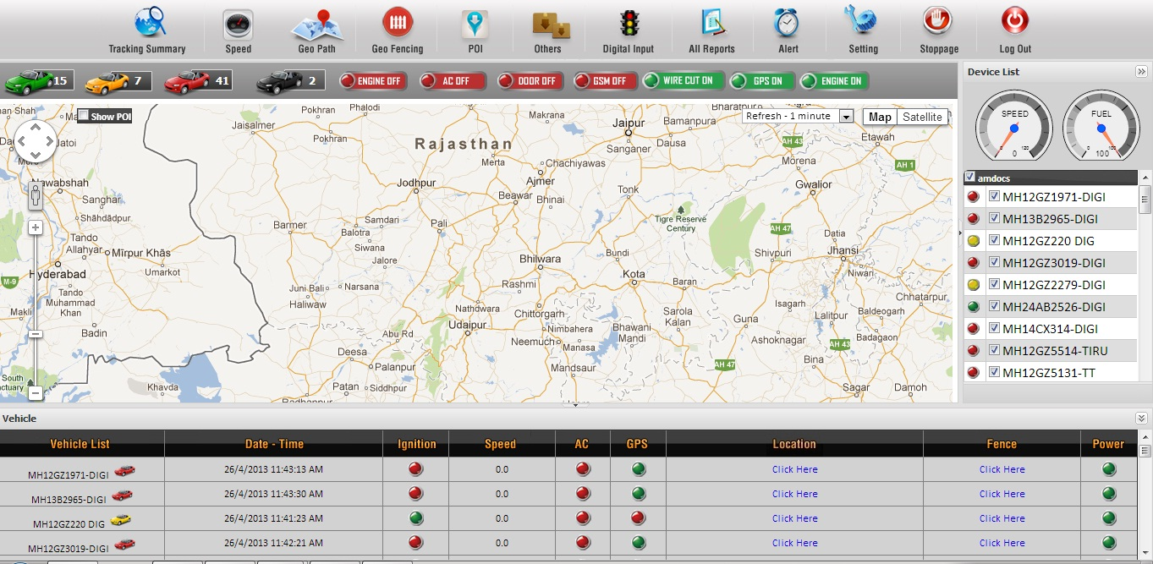

Consolidated view of all vehicles:
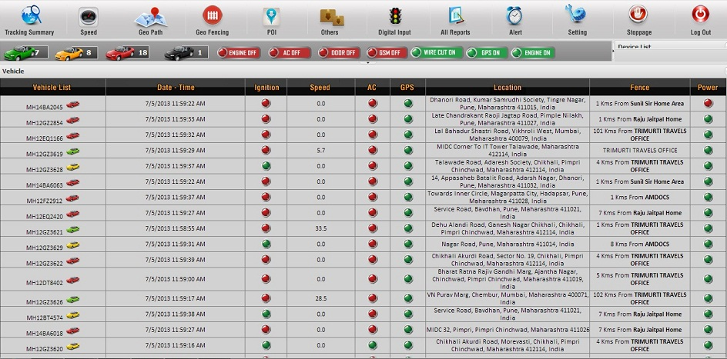

Map view of one vehicle:
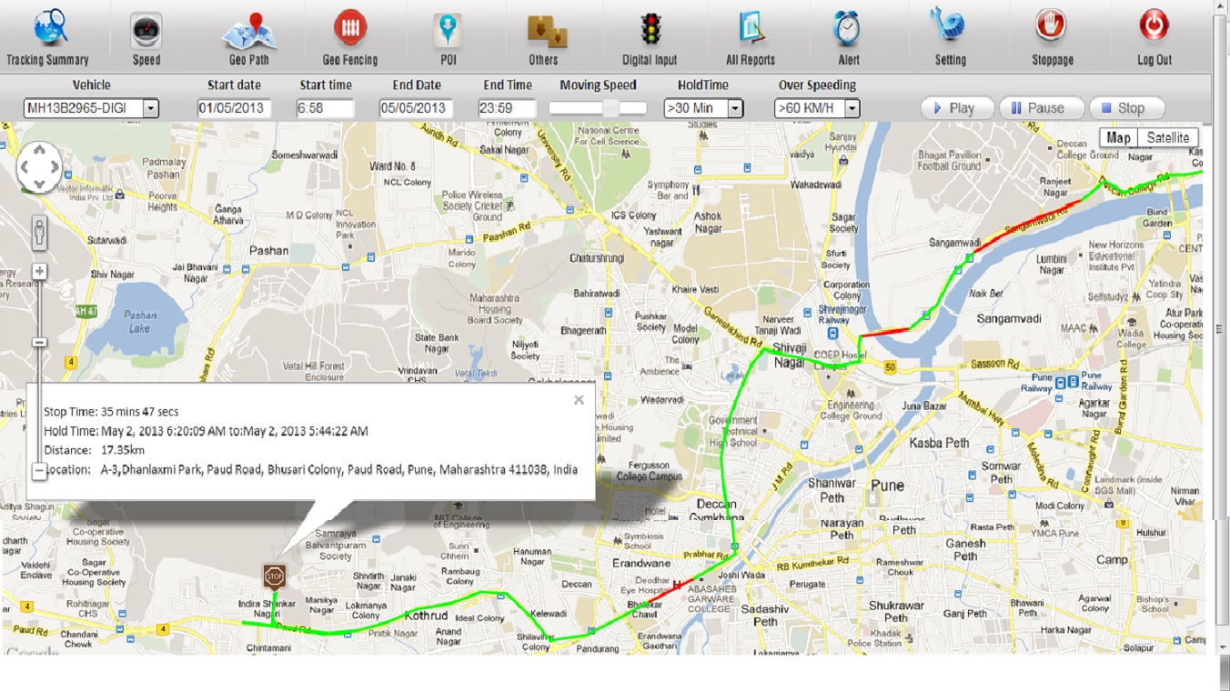

Multiple Tracking: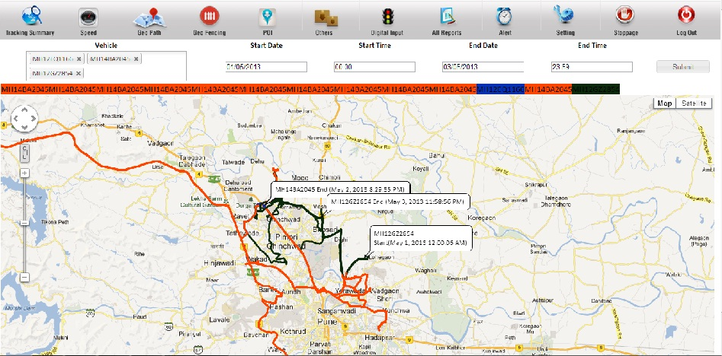

Digital Input:
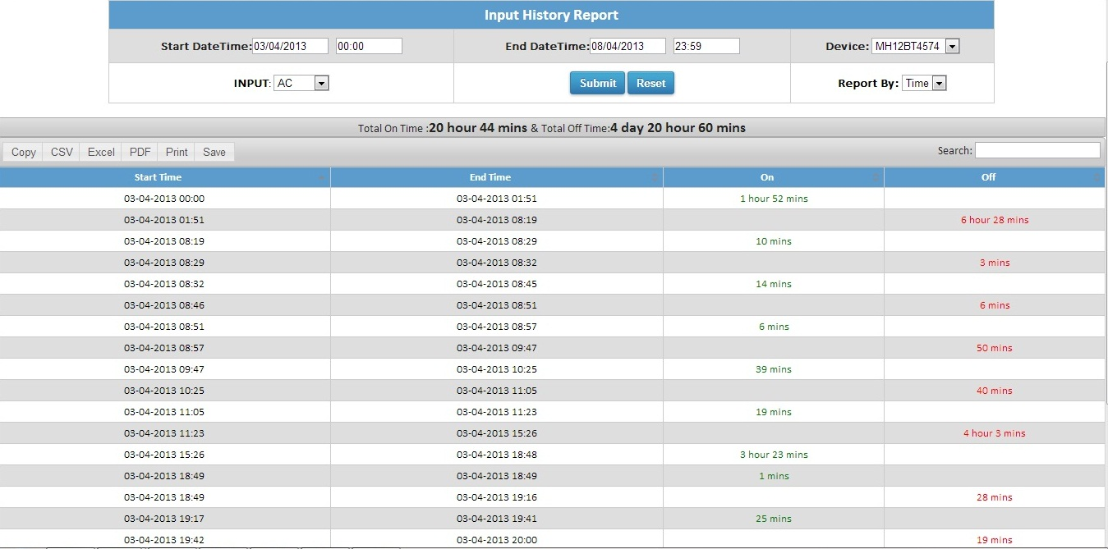

Trip Summary: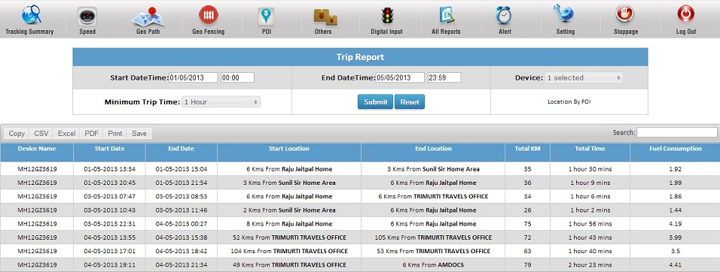

Stoppage summary
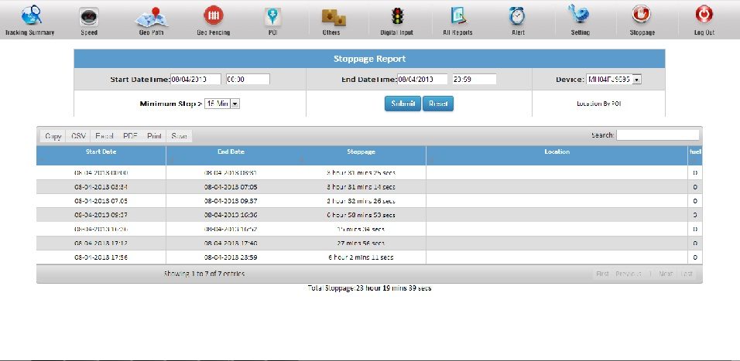

THANK YOU

